Отчёт по лабораторной работе №7 по

управлению данными

*Гайфиев Иван Алексеевич*

*Булычев Андрей Сергеевич*

*Староверов Роман Александрович*

*Дементьев Леонид Васильевич*

*Николаев Никита Дмитриевич*

*Агафонов Алексей Львович*

*студенты 23КНТ-1*

*НИУ ВШЭ НН*

Формулировки заданий и решения:

## 4. Создать запросы для вывода:

**a) всех различных размеров налогов;**

**db.employees.distinct("tax")**

**b) всех различных мест работы;**

**db.place_of_work.distinct("organisation_name")**

**c) всех различных районов проживания сотрудников.**

**db.employees.distinct("address")**

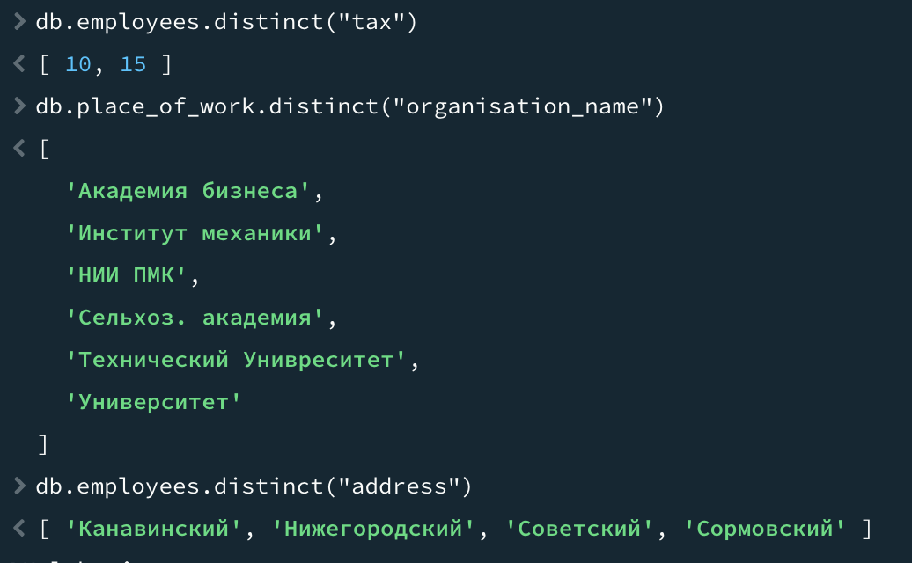

## Создав запрос получить следующую информацию:

* 1. фамилии и адреса сотрудников, имеющих налог более 8%;

**db.employees.find({tax: {$gt: 8}}, {_id:0, tax:0})**

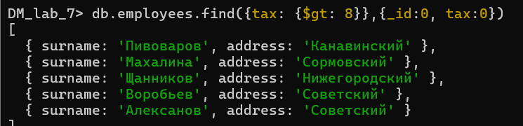

* 1. почасовую оплату и название для должностей, в названии которых встречаются слова “научный сотрудник”;

**db.job_title.find({name: {$regex: "научный сотрудник", $options: "i"}}, {_id: 0, max_hours: 0})**

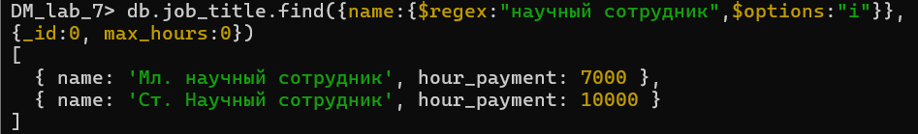

* 1. номер, дату и количество часов для тех записей о работе, где плата превышала 100000руб.

**db.job.find({salary_rub: {$gt: 100000}}, {_id: 0, id_employee: 0, id_place_of_work: 0, id_job_title: 0, salary_rub: 0})**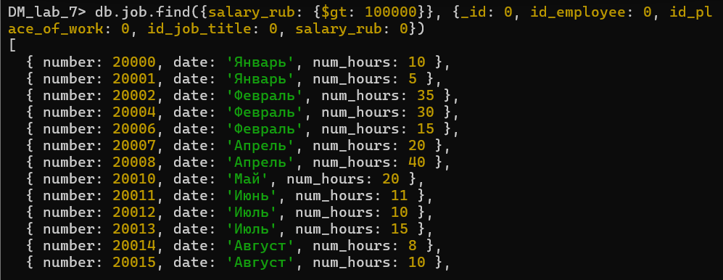

## На основании данных о работе вывести все данные в таком формате:

* 1. номер, фамилия сотрудника, дата, количество часов. Отсортировать по количеству часов;

**db.job.aggregate([**

**{**

**$lookup: {**

**from: "employees", localField: "id_employee", foreignField: "_id", as: "employee"**

**}**

**},**

**{ $unwind: "$employee" },**

**{**

**$project: {**

**_id: 0, number: 1, surname: "$employee.surname", date: 1, num_hours: 1**

**}**

**},**

**{ $sort: { num_hours: 1 } }**

**])**

**.forEach(doc => {**

**printjson({**

**number: doc.number, surname: doc.surname, date: doc.date, num_hours: doc.num_hours })})**

* 1. название работы, должность, дата, плата.

**db.job.aggregate([**

**{**

**$lookup: {**

**from: "place_of_work", localField: "id_place_of_work", foreignField: "_id", as: "pow"**

**}**

**},**

**{ $unwind: "$pow" },**

**{**

**$lookup: {**

**from: "job_title", localField: "id_job_title", foreignField: "_id", as: "jt"**

**}**

**},**

**{ $unwind: "$jt" },**

**{**

**$project: {**

**_id: 0, organisation_name: "$pow.organisation_name", job_title_name: "$jt.name", date: 1, salary_rub: 1**

**}**

**}**

**])**

**.forEach(doc => {**

**printjson({**

**organisation_name: doc.organisation_name, job_title_name: doc.job_title_name, date: doc.date, salary_rub: doc.salary_rub**

**})**

**})**

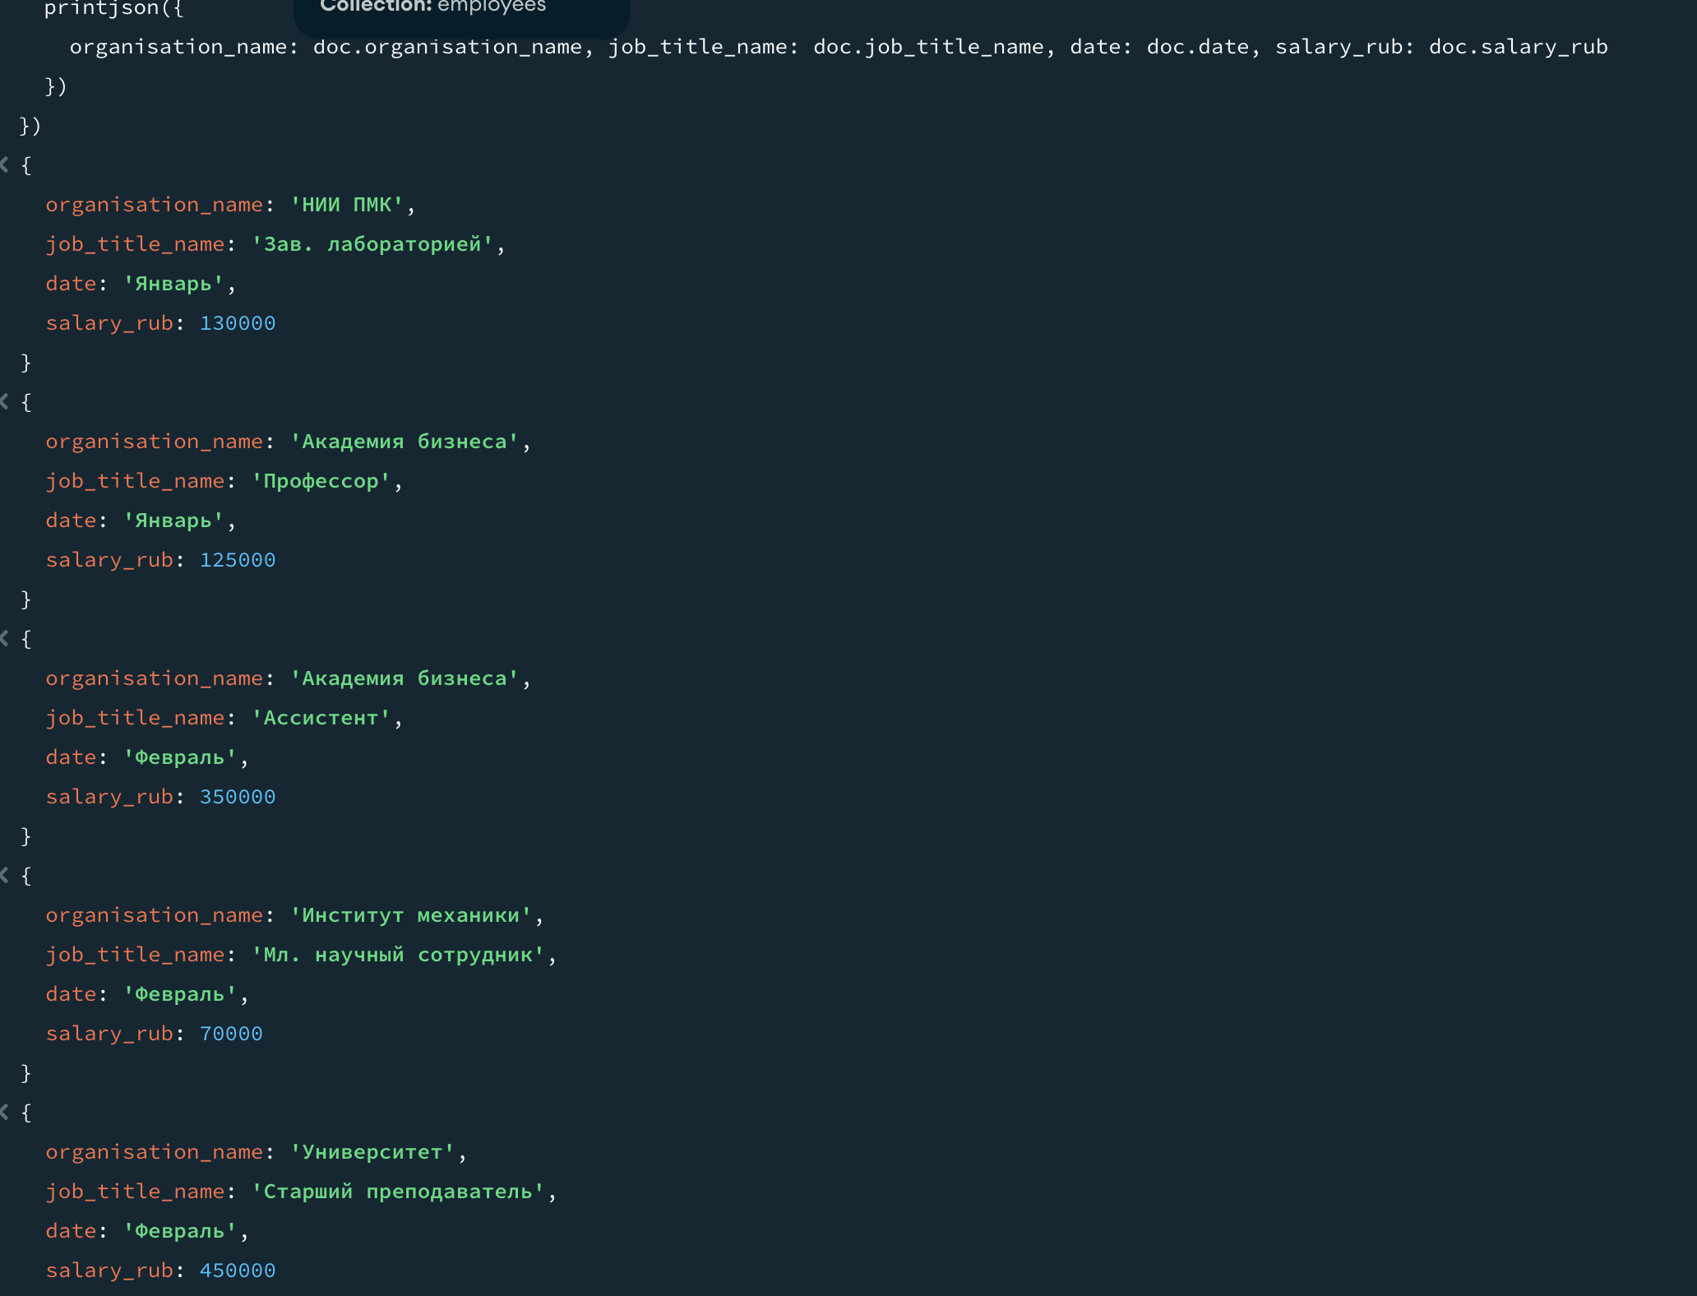

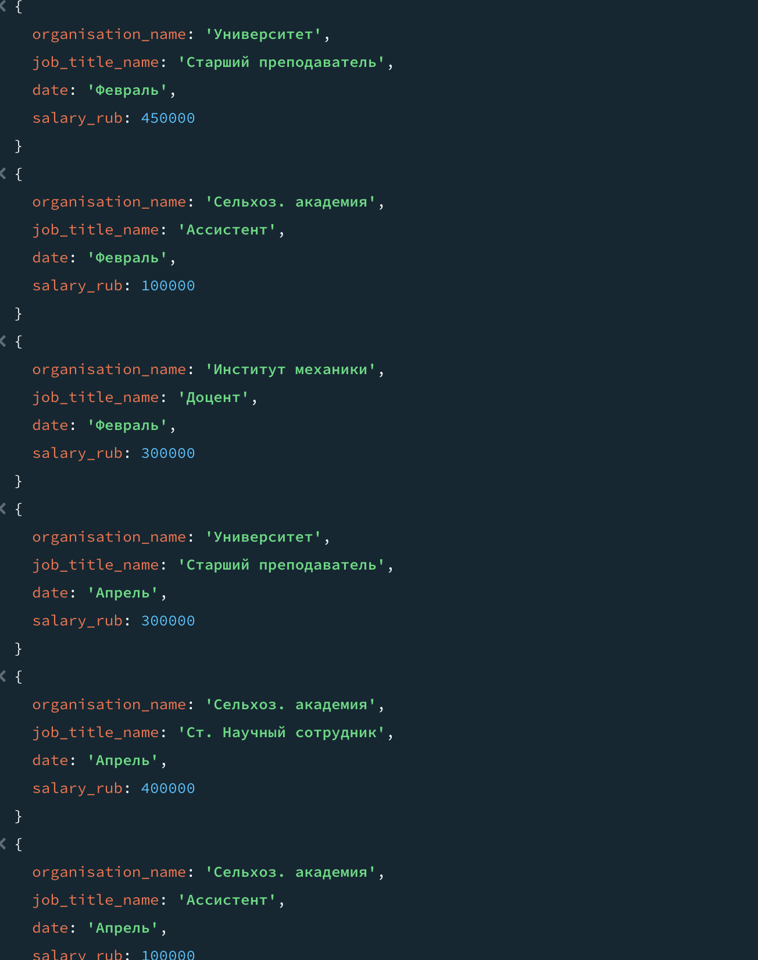

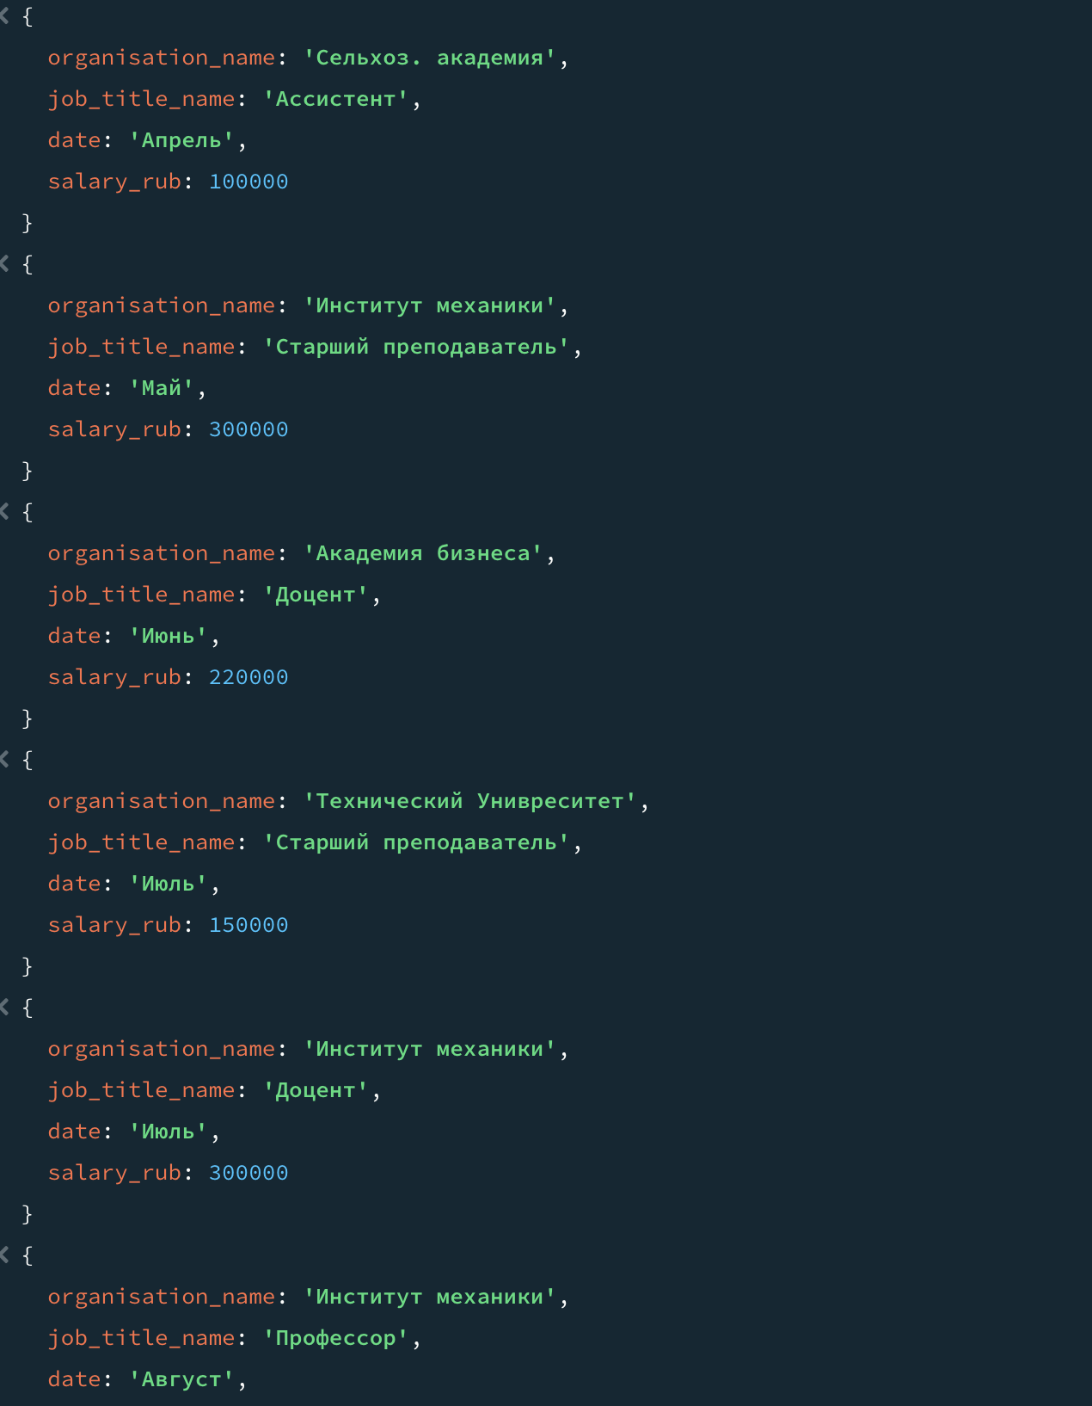

## Вывести:

* 1. названия организаций, где работали доценты или служащие того же района;

**db.job.aggregate([{**

**$lookup: {from: "place_of_work",**

**localField: "id_place_of_work",**

**foreignField: "_id",**

**as: "place_of_work_info"}},**

**{$unwind: "$place_of_work_info"},**

**{$lookup: {from: "employees",**

**localField: "id_employee",**

**foreignField: "_id",**

**as: "employee_info" }},**

**{$unwind: "$employee_info"},**

**{$match: {$or: [{ "id_job_title": 3 },{ "employee_info.address": "$place_of_work_info.address"}]}},**

**{$project: {_id: 0, organisation_name: "$place_of_work_info.organisation_name"}},**

**{$group: {_id: "$organisation_name", organisation_name: { $first: "$organisation_name" }}},**

**{$project: {_id: 0, organisation_name: 1}}]);**

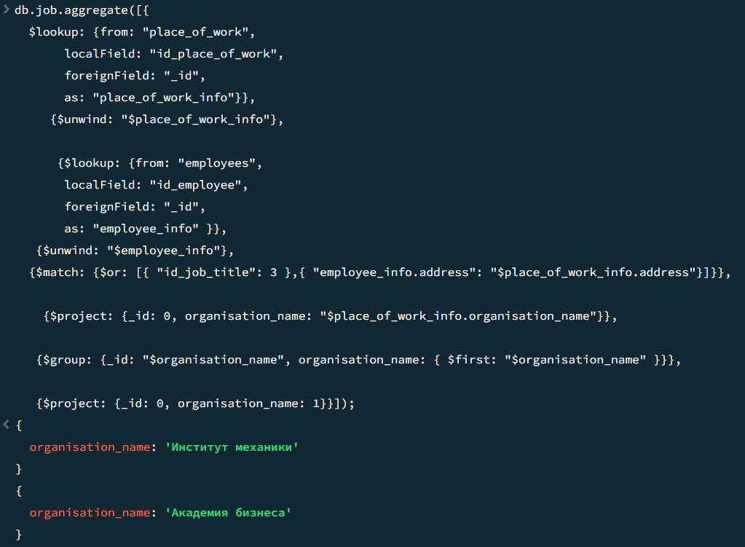

* 1. фамилии и размер налога для тех работников, которые имели работу с почасовой оплатой менее 15000руб. не ранее января;

**db.job.aggregate([**

**{$lookup:**

**{from: "employees",**

**localField: "id_employee",**

**foreignField: "_id",**

**as: "employees_info"}},**

**{$unwind: "$employees_info"},**

**{$lookup:**

**{from: "job_title",**

**localField: "id_job_title",**

**foreignField: "_id",**

**as: "job_title_info"}},**

**{$unwind: "$job_title_info"},**

**{$match: {$and: [{"job_title_info.hour_payment": {$lt : 15000}}, {"date": {$in: ["Январь", "Февраль", "Март"]}}]}},**

**{$project: {_id: 0, employee_surname: "$employees_info.surname", employee_tax: "$employees_info.tax"}}]);**

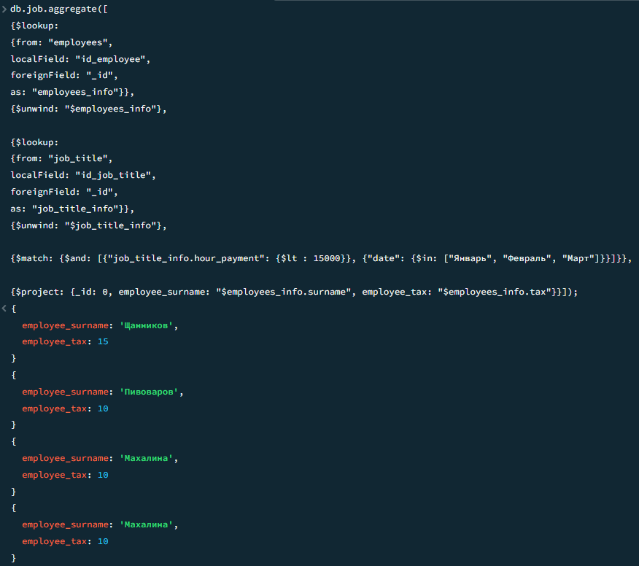

* 1. название и размер отчислений для организаций, где работал Александров более одного раза.

**db.job.aggregate([**

**{$lookup:**

**{from: "employees",**

**localField: "id_employee",**

**foreignField: "_id",**

**as: "employee_info"}},**

**{$unwind: "$employee_info" },**

**{$match: {"employee_info.surname": "Александров"}},**

**{$lookup:**

**{from: "place_of_work",**

**localField: "id_place_of_work",**

**foreignField: "_id",**

**as: "place_of_work_info"}},**

**{$unwind: "$place_of_work_info" },**

**{$group: {_id: "$id_place_of_work", count: {$sum: 1},**

**place_of_work_info: {$first: "$place_of_work_info"}}},**

**{$match: {count: {$gt: 1}}},**

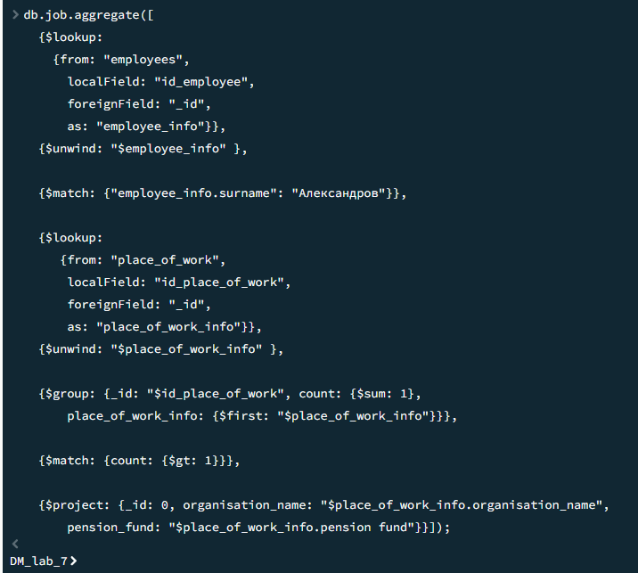

* 1. номер работы, название организации, где работали работники из Советского района. Добавить в вывод фамилии таких работников и отсортировать по названию организации.

**db.job.aggregate([**

**{$lookup:**

**{from: "employees",**

**localField: "id_employee",**

**foreignField: "_id",**

**as: "employees_info"}},**

**{$unwind: "$employees_info"},**

**{$lookup:**

**{from: "place_of_work",**

**localField: "id_place_of_work",**

**foreignField: "_id",**

**as: "place_of_work_info"}},**

**{$unwind: "$place_of_work_info"},**

**{$match: {"employees_info.address": "Советский"}},**

**{$project: {_id: 0, number: 1, organisation_name: "$place_of_work_info.organisation_name", worker_surname: "$employees_info.surname"}},**

**{$sort: {organisation_name: 1}}]);**

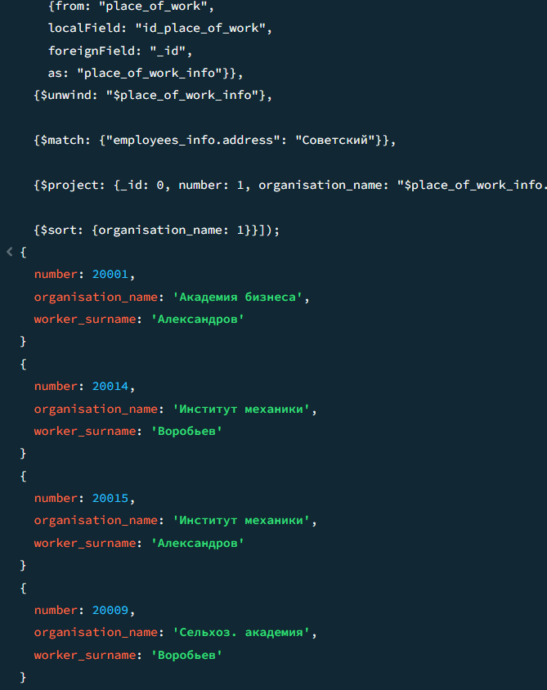

## 10. Используя операцию IN (NOT IN) реализовать следующие запросы:

* 1. найти такие места работы, где не трудились сотрудники из Приокского района;

**db.job.aggregate([**

**{$lookup:**

**{from: "employees",**

**localField: "id_employee",**

**foreignField: "_id",**

**as: "employee_info"}},**

**{$unwind: "$employee_info"},**

**{$lookup:**

**{from: "place_of_work",**

**localField: "id_place_of_work",**

**foreignField: "_id",**

**as: "place_info"}},**

**{$unwind: "$place_info"},**

**{$match: {"employee_info.address": "Приокский"}},**

**{$group: {_id: null, names: {$addToSet: "$place_info.organisation_name"}}},**

**{$project: {names: 1, other_list: {$setUnion: [["Академия бизнеса",**

**"Сельхоз. академия", "НИИ ПМК", "Технический Университет",**

**"Институт механики", "Университет"]]}}},**

**{$project: {difference: {$filter: {input: "$names", as: "diff", cond: {$not: {$in: ["$$diff", "$other_list"]}}}}}}])**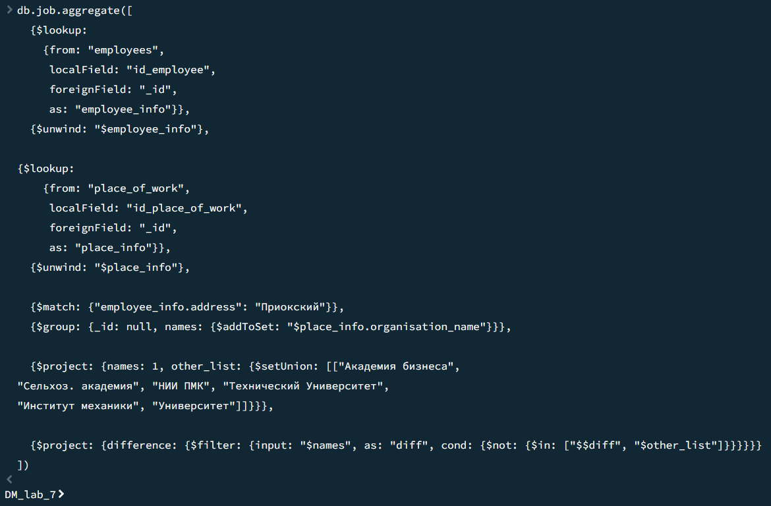

* 1. запросы задания 7.а и 7.d;

**db.job.aggregate([{**

**$lookup: {from: "place_of_work",**

**localField: "id_place_of_work",**

**foreignField: "_id",**

**as: "place_of_work_info"}},**

**{$unwind: "$place_of_work_info"},**

**{$lookup: {from: "employees",**

**localField: "id_employee",**

**foreignField: "_id",**

**as: "employee_info" }},**

**{$unwind: "$employee_info"},**

**{$match: {$or: [{ "id_job_title": {$in: [3]} },{ "employee_info.address": "$place_of_work_info.address"}]}},**

**{$project: {_id: 0, organisation_name: "$place_of_work_info.organisation_name"}},**

**{$group: {_id: "$organisation_name", organisation_name: { $first: "$organisation_name" }}},**

**{$project: {_id: 0, organisation_name: 1}}]);**  
  
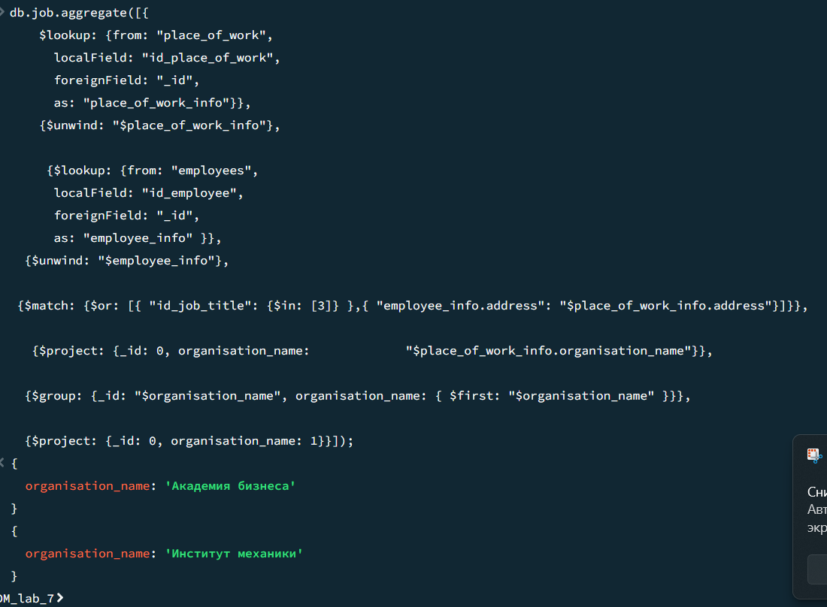

**db.job.aggregate([**

**{$lookup:**

**{from: "employees",**

**localField: "id_employee",**

**foreignField: "_id",**

**as: "employees_info"}},**

**{$unwind: "$employees_info"},**

**{$lookup:**

**{from: "place_of_work",**

**localField: "id_place_of_work",**

**foreignField: "_id",**

**as: "place_of_work_info"}},**

**{$unwind: "$place_of_work_info"},**

**{$match: {"employees_info.address": {$in:["Советский"]}}},**

**{$project: {_id: 0, number: 1, organisation_name: "$place_of****_work_info.organisation_name", worker_surname: "$employees_info.surname"}},**

**{$sort: {organisation_name: 1}}]);db.place_of_work.d**  
  
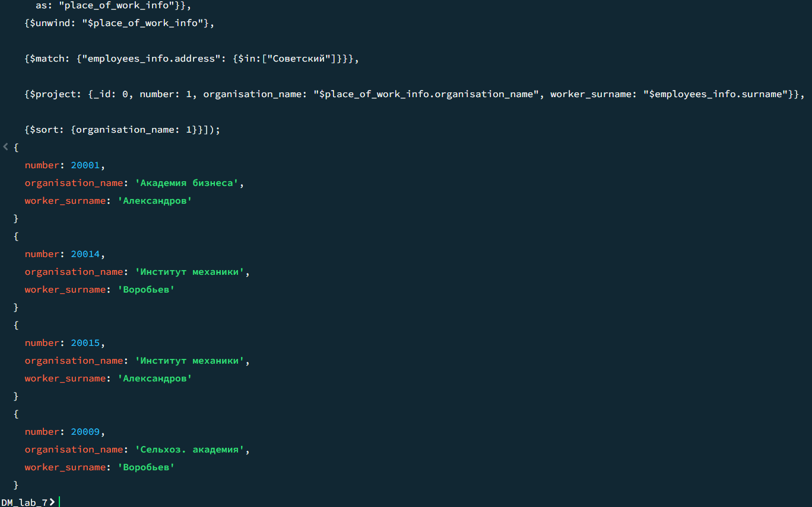

* 1. определить должности, на которых работал Пивоваров более раза.

**db.job.aggregate([**

**{$lookup:**

**{from: "employees",**

**localField: "id_employee",**

**foreignField: "_id",**

**as: "employees_info"}},**

**{$unwind: "$employees_info"},**

**{$lookup:**

**{from: "job_title",**

**localField: "id_job_title",**

**foreignField: "_id",**

**as: "title_info"}},**

**{$unwind: "$title_info"},**

**{$match: {"employees_info.surname": {$in: ["Пивоваров"]}}},**

**{$group: {_id: "$title_info.name", count: {$sum: 1}}},**

**{$match: {count: {$gt: 1}}},**

**{$project: {_id: 0, title_name: "$_id"}}]);**

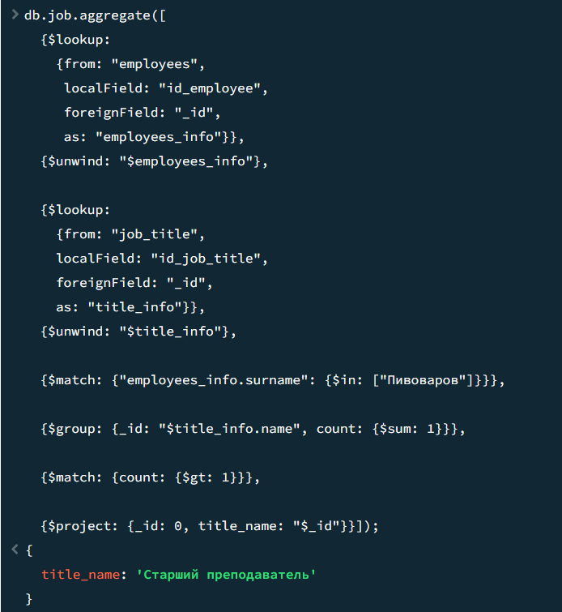

## 11. Используя операции ALL-ANY реализовать следующие запросы:

* 1. найти должность с самой высокой почасовой оплатой;

**var maxPayment = db.job_title.aggregate([**

**{ $group: { _id: null, maxPayment: { $max: "$hour_payment" } } }**

**]).toArray()[0].maxPayment;**

**db.job_title.find({ hour_payment: maxPayment }).forEach(doc => printjson(doc));**

* 1. найти место работы, где на самой низкооплачиваемой должности работал Воробьев;

**db.job.aggregate([**

**{ $match: { id_employee: 4 } },**

**{ $lookup: {**

**from: "job_title", localField: "id_job_title", foreignField: "_id", as: "jt"**

**} },**

**{ $unwind: "$jt" },**

**{ $sort: { "jt.hour_payment": 1 } },**

**{ $limit: 1 },**

**{ $lookup: {**

**from: "place_of_work", localField: "id_place_of_work", foreignField: "_id", as: "pow"**

**} },**

**{ $unwind: "$pow" },**

**{ $project: {**

**_id: 0, organisation_name: "$pow.organisation_name", address: "$pow.address" }}]).forEach(doc => printjson(doc));**

* 1. среди работавших в университете найти сотрудника с самым низким налогом;

**db.job.aggregate([**

**{ $lookup: {**

**from: "place_of_work", localField: "id_place_of_work", foreignField: "_id", as: "pow"**

**} },**

**{ $unwind: "$pow" },**

**{ $match: { "pow.organisation_name": "Университет" } },**

**{ $lookup: {**

**from: "employees", localField: "id_employee", foreignField: "_id", as: "emp"**

**} },**

**{ $unwind: "$emp" },**

**{ $group: {**

**_id: "$emp._id", surname: { $first: "$emp.surname" }, tax: { $first: "$emp.tax" }**

**} },**

**{ $sort: { tax: 1 } },**

**{ $limit: 1 }**

**])**

**.forEach(doc => printjson(doc));**

* 1. название и размер отчислений для организаций, где работал Александров более одного раза.

**var emp = db.employees.findOne({ surname: "Алексанов" });**

**if (emp) {**

**db.job.aggregate([**

**{ $match: { id_employee: emp._id } },**

**{ $group: {**

**_id: "$id_place_of_work", jobCount: { $sum: 1 }**

**} },**

**{ $match: { jobCount: { $gt: 1 } } },**

**{ $lookup: {**

**from: "place_of_work", localField: "_id", foreignField: "_id", as: "pow"**

**} },**

**{ $unwind: "$pow" },**

**{ $project: {**

**_id: 0, organisation_name: "$pow.organisation_name", pension_fund: "$pow['pension fund']"} } ]) .forEach(doc => printjson(doc));}**

## 12. Используя операцию UNION получить адреса проживания сотрудников и места расположения организаций.

**db.employees.aggregate([**

**{**

**$project: {**

**_id: 0,**

**address: 1,**

**belongsTo: "$surname",**

**type: { $literal: "employee" } } },**

**{**

**$unionWith: {**

**coll: "place_of_work",**

**pipeline: [**

**{**

**$project: {**

**_id: 0,**

**address: 1,**

**belongsTo: "$organisation_name",**

**type: { $literal: "organization" }}}] }, {**

**$sort: { address: 1 }**

**}**

**])**

**.forEach(doc => printjson(doc));**

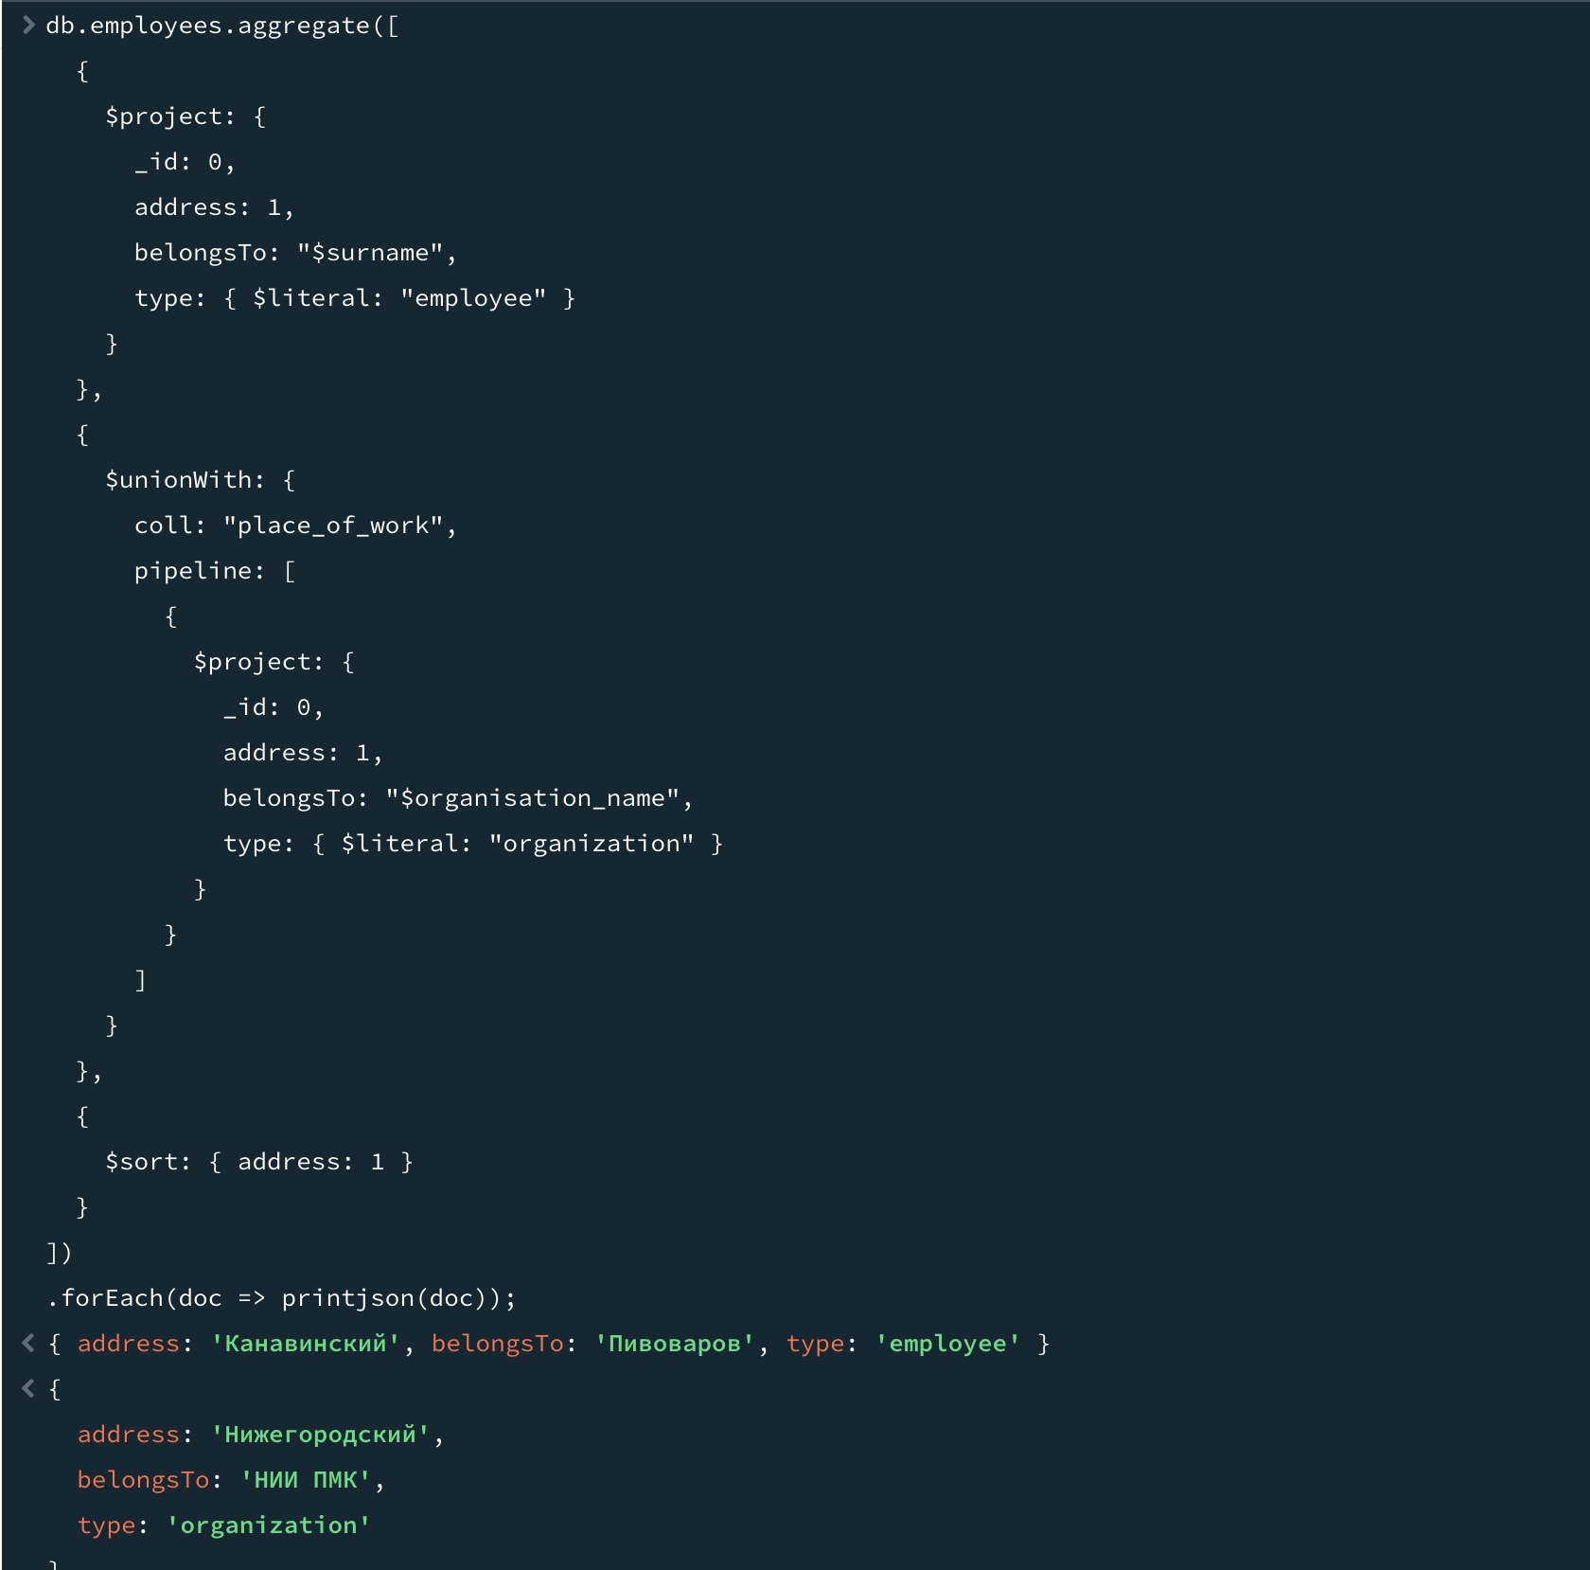

## 13. Используя операцию EXISTS ( NOT EXISTS ) реализовать нижеследующие запросы. В случае, если для текущего состояния БД запрос будет выдавать пустое множество строк, требуется указать какие добавления в БД необходимо провести.

a. найти сотрудников, работавших на должности доцента во всех организациях;  
**var totalOrgs = db.place_of_work.countDocuments({});**

**db.employees.aggregate([**

**{**

**$lookup: {**

**from: "job",**

**let: { empId: "$_id" },**

**pipeline: [**

**{**

**$match: { $expr: { $and: [**

**{ $eq: ["$id_employee", "$$empId"] }, { $eq: ["$id_job_title", 3] }]} } },**

**{ $group: {**

**_id: "$id_place_of_work" } } ],**

**as: "dozentOrgs" } },**

**{ $addFields: {**

**dozentCount: { $size: "$dozentOrgs" } } },**

**{**

**$match: { dozentCount: totalOrgs } },**

**b. найти места работы на которых работали все сотрудники из Приокского или Сормовского районов;

**db.place_of_work.aggregate([**

**{**

**$lookup: {**

**from: "employees",**

**let: { placeId: "$_id" },**

**pipeline: [**

**{**

**$match: {**

**$or: [**

**{ address: { $regex: /Приокский/i } }, { address: { $regex: /Сормовский/i } }]}**

**},**

**{ $project: { _id: 1 } }**

**],**

**as: "allPotentialEmp"**

**}**

**},**

**{**

**$lookup: {**

**from: "job", localField: "_id", foreignField: "id_place_of_work", as: "jobs"**

**}**

**},**

**{**

**$addFields: {**

**potentialEmp: {**

**$map: {**

**input: "$allPotentialEmp._id", as: "peId", in: { $toString: "$$peId" }**

**}**

**},**

**actualEmp: {**

**$map: {**

**input: "$jobs.id_employee", as: "aeId", in: { $toString: "$$aeId" }**

**}}}**

**},**

**{**

**$match: {**

**$expr: {**

**$setIsSubset: [**

**"$potentialEmp",**

**"$actualEmp"**

**]**

**}**

**}**

**},**

**{**

**$project: {**

**_id: 0, organisation_name: 1, address: 1**

**}**

**}**

**])**

**

c. определить должности на которых не работали сотрудники в организациях чужих районов;

**db.job.aggregate([**

**{**

**$lookup: {**

**from: "employees", localField: "id_employee", foreignField: "_id", as: "emp"**

**}**

**},**

**{ $unwind: "$emp" },**

**{**

**$lookup: {**

**from: "place_of_work", localField: "id_place_of_work", foreignField: "_id", as: "pow"**

**}**

**},**

**{ $unwind: "$pow" },**

**{**

**$project: {**

**id_job_title: 1, diff: { $ne: ["$emp.address", "$pow.address"] } } },**

**{ $group: {**

**_id: "$id_job_title", allDiff: { $min: "$diff" }**

**}},**

**{ $match: { allDiff: true } },**

**{ $lookup: { from: "job_title", localField: "_id", foreignField: "_id", as: "jt"} },**

**{ $unwind: "$jt" },**

**{ $project: {**

**_id: 0,**

**job_title: "$jt.name"**

**}}**

**

d. найти сотрудника и должность, в которой этот сотрудник проработал во всех организациях Нижегородского или Сормовского районов.

**{ $addFields: { id_place_of_work_str: { $toString: "$id_place_of_work" } } },**

**{ $match: { id_place_of_work_str: { $in: targetOrgs } } },**

**{**

**$group: {**

**_id: { employee: "$id_employee", jobTitle: "$id_job_title" },**

**orgs: { $addToSet: "$id_place_of_work_str" } }},**

**{ $match: {**

**$expr: { $eq: [ { $size: "$orgs" }, totalTargetOrgs }},**

**{ $lookup: { from: "employees", localField: "_id.employee", foreignField: "_id", as: "emp" } },**

**{ $unwind: "$emp" },**

**{ $lookup: {**

**from: "job_title", localField: "_id.jobTitle", foreignField: "_id", as: "jt" } },**

**{ $unwind: "$jt" },**

**{ $project: {**

**_id: 0, surname: "$emp.surname", job_title: $jt.name" }}**

**]).forEach(doc => printjson(doc));**

## 14. Реализовать запросы с использованием аггрегатных функций:

а) найти число различных работников, трудившихся в должности ассистента до ноября;

**db.job.aggregate([**

**{$match: {**

**date: {**

**$in: [**

**"Январь", "Февраль", "Март", "Апрель",**

**"Май", "Июнь", "Июль", "Август",**

**"Сентябрь", "Октябрь" ]}}},**

**{$lookup: {**

**from: "job_title", localField: "id_job_title", foreignField: "_id", as: "jt"}},**

**{ $unwind: "$jt" },**

**{$match: {"jt.name": "Ассистент"}},**

**{$group: {_id: "$id_employee"}},**

**{ $count: "count_of_assistants_before_november"}]);**

1. определить среднюю величину отчислений для тех организаций, где трудились сотрудники с налогом менее 15%;

**db.job.aggregate([**

**{**

**$lookup: {**

**from: "employees", localField: "id_employee", foreignField: "_id", as: "emp"**

**}**

**},**

**{ $unwind: "$emp" },**

**{**

**$match: {**

**"emp.tax": { $lt: 15 }**

**}**

**},**

**{**

**$lookup: {**

**from: "place_of_work", localField: "id_place_of_work", foreignField: "_id", as: "pow"**

**}**

**},**

**{ $unwind: "$pow" },**

**{**

**$group: {**

**_id: { placeOfWorkId: "$pow._id", organisation_name: "$pow.organisation_name"**

**},**

**average: {**

**$avg: {**

**$multiply: [ "$salary_rub",{ $divide: ["$pow.pension fund", 100] }]**

**} } }},**

**{**

**$project: {**

**_id: 0,**

**organisation_name: "$_id.organisation_name",**

**average: 1**

**}**

**}])**

**.forEach(doc => printjson(doc));**

1. найти число сотрудников, работавших до марта в университете;

**db.job.aggregate([**

**{**

**$match: {**

**date: { $in: ["Январь", "Февраль"] }**

**}**

**},**

**{**

**$lookup: {**

**from: "place_of_work",**

**localField: "id_place_of_work",**

**foreignField: "_id",**

**as: "pow"**

**}**

**},**

**{ $unwind: "$pow" },**

**{**

**$match: {**

**"pow.organisation_name": "Университет" } },**

**{ $group: {**

**_id: "$id_employee" } },**

**{ $count: "count_of_employees_in_university_before_march" }])**

**.forEach(doc => printjson(doc));**

1. какие работники получали плату выше средней.

**db.job.aggregate([**

**{**

**$lookup: {**

**from: "employees", localField: "id_employee", foreignField: "_id", as: "emp"**

**}**

**},**

**{ $unwind: "$emp" },**

**{**

**$set: {**

**netPay: {**

**$multiply: [**

**"$salary_rub", {$subtract: [1, { $divide: ["$emp.tax", 100] }] }]}**

**}**

**},**

**{**

**$setWindowFields: {**

**partitionBy: null,**

**output: {**

**avgNetPay: { $avg: "$netPay" } } }**

**},**

**{**

**$match: {**

**$expr: { $gt: ["$netPay", "$avgNetPay"] }**

**}**

**},**

**{**

**$group: {**

**_id: "$emp._id", surname: { $first: "$emp.surname" }, netPayAboveAvg: { $addToSet: "$netPay" }**

**} },**

**{**

**$project: {**

**_id: 0, surname: 1, netPayAboveAvg: 1 } }])**

**.forEach(doc => printjson(doc));**

## 15. Используя средства группировки реализовать следующие запросы:

* 1. найти должности, на которых работало более трех человек;

**db.job.aggregate([**

**{$lookup:**

**{from: "job_title",**

**localField: "id_job_title",**

**foreignField: "_id",**

**as: "title_info"}},**

**{$unwind: "$title_info"},**

**{$group: {_id: "$title_info.name", count: {$sum: 1}}},**

**{$match: {count: {$gt: 3}}},**

**{$project: {_id: 0, title_name: "$_id"} }**

**]);**

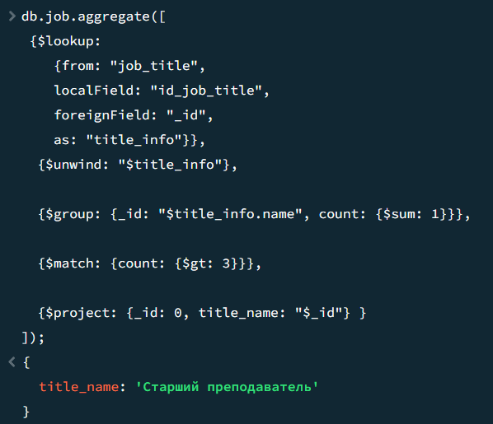

* 1. найти для каждого сотрудника максимальную получаемую плату;

**db.job.aggregate([**

**{$lookup:**

**{from: "employees",**

**localField: "id_employee",**

**foreignField: "_id",**

**as: "employee_info"}},**

**{$unwind: "$employee_info"},**

**{$group: {_id: "$employee_info.surname", max_salary: {$max: "$salary_rub"}}},**

**{$project: {_id: 0, emp_name: "$_id", max_salary: 1}}**

**]);**

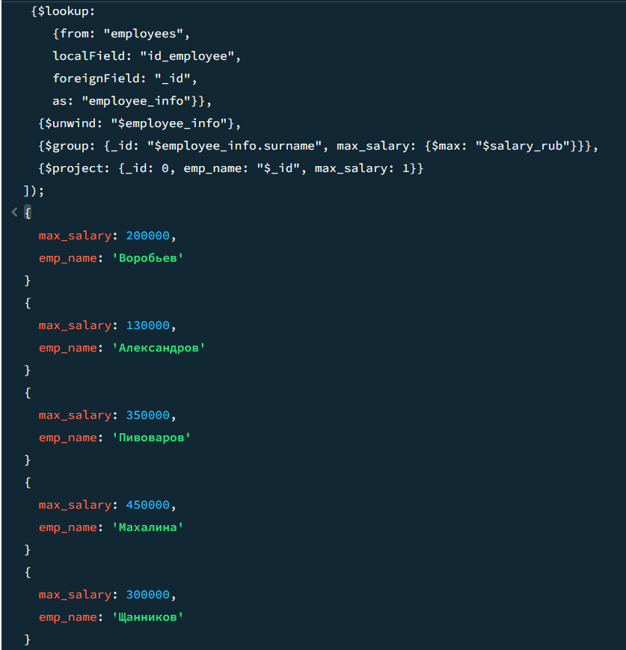

* 1. какие организации за месяц тратили на зарплату более 1000000;

**db.job.aggregate([**

**{$lookup:**

**{from: "place_of_work",**

**localField: "id_place_of_work",**

**foreignField: "_id",**

**as: "place_info"}},**

**{$unwind: "$place_info"},**

**{$group: {_id: {month: "$date", place_name: "$place_info.name"}, sum_salary: {$sum: "$salary_rub"}}},**

**{$group: {_id: "$_id.month", organisations: {$push: {place_name: "$_id.place_name", sum_salary: "$sum_salary"}}}},**

**{$match: {"organisations.sum_salary": {$gt: 1000000}}},**

**{$project: {_id: 0, organizations:**

**{$filter: {input: "$organizations", as: "org", cond: { $gt: ["$$org.sum_salary", 1000000]}}}}},**

**]);**

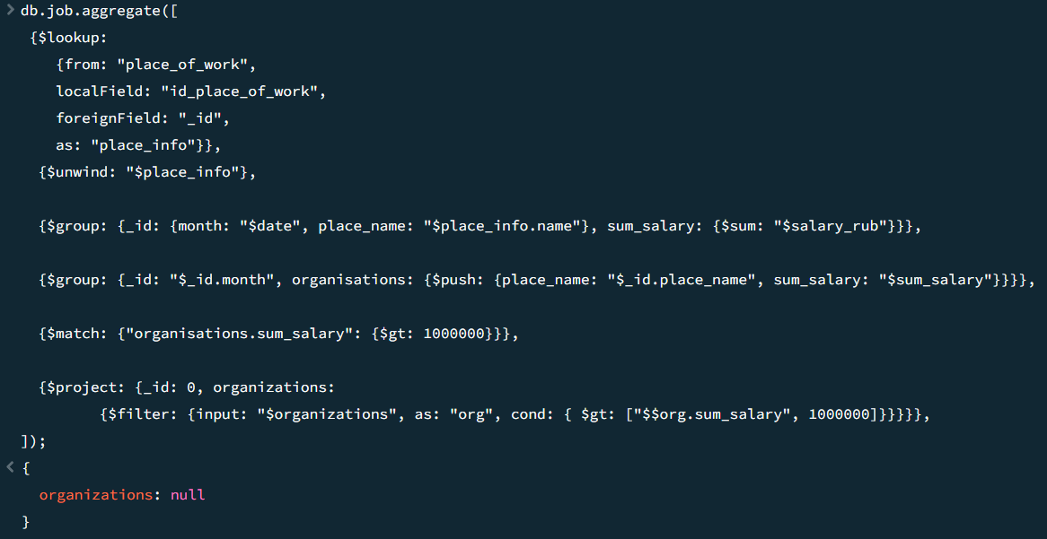

* 1. получить для каждой организации из Нижегородского или Сормовского района среднее число часов, которое нарабатывали сотрудники.

**db.job.aggregate([**

**{$lookup:**

**{from: "place_of_work",**

**localField: "id_place_of_work",**

**foreignField: "_id",**

**as: "place_info"}},**

**{$unwind: "$place_info"},**

**{$match: {"place_info.address" : {$in: ["Нижегородский", "Сормовский"]}}},**

**{$group: {_id: "$place_info.organisation_name", average_hours: {$avg: "$num_hours"}}},**

**{$project: {_id: 0, organisation_name: "$_id", average_hours: 1}}])**